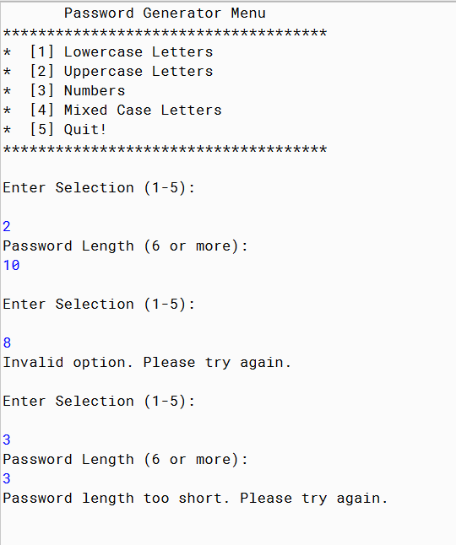

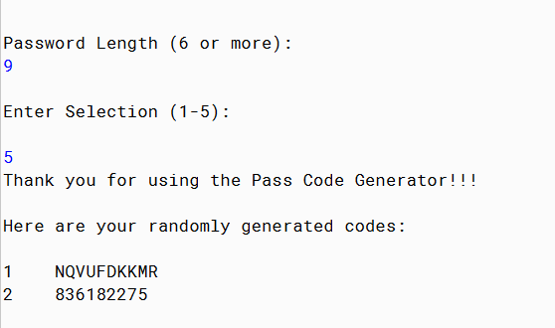

PMR: This program was quite challenging. The loops in my opinion are hard to configure and it took a lot of trouble shooting. In all honesty I did not enjoy building this program and it frustrated me.

/\*\*

\* The class SecretPasscodes generates random passwords based on four different options.

\*

\* @Anika Jallipalli

\* @10/30/2019

\*/

import java.util.Scanner;

import java.io.File;

import java.io.IOException;

import java.io.PrintWriter;

public class SecretPasscodes

{

public static void main(String[] args) throws IOException

{

int randNum;

PrintWriter outFile = new PrintWriter(new File("password.txt"));

Scanner input = new Scanner(System.in);

System.out.println(" Password Generator Menu ");

System.out.println("\*\*\*\*\*\*\*\*\*\*\*\*\*\*\*\*\*\*\*\*\*\*\*\*\*\*\*\*\*\*\*\*\*\*\*\*\*");

System.out.println("\* [1] Lowercase Letters ");

System.out.println("\* [2] Uppercase Letters ");

System.out.println("\* [3] Numbers ");

System.out.println("\* [4] Mixed Case Letters ");

System.out.println("\* [5] Quit! ");

System.out.println("\*\*\*\*\*\*\*\*\*\*\*\*\*\*\*\*\*\*\*\*\*\*\*\*\*\*\*\*\*\*\*\*\*\*\*\*\*");

boolean repeat = true;

while (repeat)

{

System.out.println("");

System.out.println("Enter Selection (1-5): ");

System.out.println("");

int selection = input.nextInt();

while (selection != 1 && selection != 2 && selection != 3 && selection != 4 && selection != 5)

{

System.out.println("Invalid option. Please try again.");

System.out.println("");

System.out.println("Enter Selection (1-5): ");

System.out.println("");

selection = input.nextInt();

}

//System.out.println(selection);

if (selection == 5)

repeat = false;

else {

System.out.println("Password Length (6 or more): ");

int length = input.nextInt();

while (length < 6)

{

System.out.println("Password length too short. Please try again.");

System.out.println("");

System.out.println("");

System.out.println("Password Length (6 or more): ");

length = input.nextInt();

}

//System.out.println(length);

if (selection == 1)

{ //System.out.println("r = " + randNum);

//System.out.println("c = " + (char)randNum);

for (int loop = 1; loop <= length; loop++)

{

randNum = (int) (Math.random() \* 25) + 97;

//System.out.print((char)randNum);

outFile.print((char)randNum);

}//end of for loop

outFile.println();

}

if (selection == 2)

{ //System.out.println("r = " + randNum);

//System.out.println("c = " + (char)randNum);

for (int loop = 1; loop <= length; loop++)

{

randNum = (int) (Math.random() \* 25) + 65;

//System.out.print((char)randNum);

outFile.print((char)randNum);

}//end of for loop

outFile.println();

}

if (selection == 3)

{ //System.out.println("r = " + randNum);

//System.out.println("c = " + (char)randNum);

for (int loop = 1; loop <= length; loop++)

{

randNum = (int) (Math.random() \* 9) + 48;

//System.out.print((char)randNum);

outFile.print((char)randNum);

}//end of for loop

outFile.println();

}

if (selection == 4)

{ //System.out.println("r = " + randNum);

//System.out.println("c = " + (char)randNum);

for (int loop = 1; loop <= length; loop++)

{

int randNum2 = (int) (Math.random() \* 2);

if (randNum2 == 0)

randNum = (int) (Math.random() \* 25) + 97;

else

randNum = (int) (Math.random() \* 25) + 65;

//System.out.print((char)randNum);

outFile.print((char)randNum);

}//end of for loop

outFile.println();

}

}

}

outFile.close ( ); //close the file when finished

System.out.println("Thank you for using the Pass Code Generator!!!");

System.out.println();

System.out.println("Here are your randomly generated codes:");

System.out.println();

//open file

String token = "";

File fileName = new File("password.txt");

Scanner inFile = new Scanner(fileName);

int count = 1;

while( inFile.hasNextLine() )

{

token = inFile.nextLine( ); //read next token from file

System.out.println(count + " " + token); //print value of token

count++;

}//end while

}

}